Unit Study: The Holocaust

Name: _________________________________

**Meeting a Holocaust Survivor**

Photo courtesy Black River Technical College

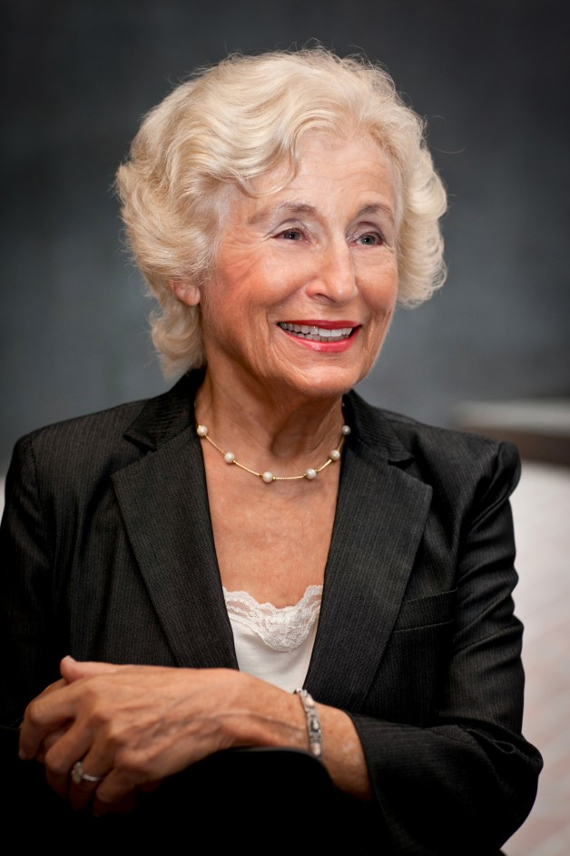

Susan (Hilsenrath) Warsinger

**Course Objectives**

* To explore why Survivor testimony is important
* To feel prepared for hearing a Holocaust Survivor
* To consider some questions you may be interested in asking a Holocaust Survivor
* To consider the experience of hearing the Survivor’s testimony and to discuss the issues raised.
* To produce a piece of work that reflects learning from hearing the Survivor.

What is testimony?

Complete the sentences below.

I think testimony is..........................................................................................................................

............................................................................................................................................................

............................................................................................................................................................

Testimony is defined as.................................................................................................................

............................................................................................................................................................

............................................................................................................................................................

Working in pairs, discuss...

What do testimonials provide to listeners?

Why are life experiences from Holocaust Survivors important?

Expectations

Look at the list of words below. Shade in the boxes that correspond with your expectations of what the Holocaust Survivor will be like. Fill in the blank boxes with words of your own. Be prepared to feedback your answers and ideas to the class.

|  |  |
| --- | --- |
| STRONG | VICTIM |
| BRAVE | RESOURCEFUL |
|  |  |
|  |  |
|  |  |
|  |  |
|  |  |
|  |  |
|  |  |
|  |  |

What does a survivor look like?

________________________________________________________________________________________________________________________________________________________________________________________________________________________

Old? White Hair? Strange Dialect? Weak? Tired? Strong-willed?

It’s important that you realize that the person who is about to come and speak to you is not an emaciated holocaust victim anymore, if they ever were. They are someone who has lived through the Second World War and rebuilt their life after it.

Write any concerns you have about meeting a Holocaust Survivor below:

............................................................................................................................................................

............................................................................................................................................................

............................................................................................................................................................

............................................................................................................................................................

............................................................................................................................................................

............................................................................................................................................................

Glossary of Terms:

**Anti-Semitism** – Prejudice or hatred of Jewish people.

**Anschluss** – The union of Germany and Austria after the Nazis invaded Austria in 1938.

**Concentration camps** – Sites such as Dachau and Buchenwald that were built by the Nazis to imprison individuals and groups of people they considered “enemies of the state” such as political opponents, Jehovah’s Witnesses and Jews.

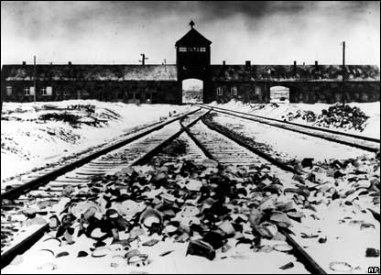

**Death Camps** – These six sites –   
Auschwitz-Birkenau, Belzec, Chelmno,   
Majdanek, Sobibor and Treblinka – were   
established by the Nazis to   
systematically murder people. These   
camps were located in Poland.

**Deportation** – The rounding up of Jews living in one place and their transportation to another. Frequently this referred to the movement of Jews in Western and Central Europe to ghettos, concentration camps and death camps in the Eastern territories. This removal commonly saw Jews transported in cattle wagons.

**Kindertransport**– German for “Children’s Transport”. A series of rescue efforts which brought nearly 10,000 refugee Jewish children to Great Britain from Germany and Austria between 1938 and the outbreak of war. Children were officially only allowed into the country on a temporary basis, and their parents were excluded for fear of increasing competition for jobs.



**Kristallnacht (9-10 November 1938)** – German for “Night of Broken Glass”. This state-sponsored event saw hundreds of synagogues burnt down, Jewish owned shops looted and large numbers of Jews physically attacked and arrested. The name of this event refers to the destruction that occurred.

**Nuremberg Laws (1935)** – These anti-Semitic laws represented a major escalation in the level of persecution directed at Germany’s Jews. From then on a person was defined as Jewish according to the number of grandparents who were Jewish. Jews were forbidden from marrying non-Jews and had their citizenship revoked.

**SS** – An abbreviation of Schutzstaffel, the German word for “Protection Squads”. These Nazis were commonly in charge of concentration camps and death camps and key perpetrators of organized mass murder.



**Star of David** – A traditional symbol of the Jewish people.  
Sewn onto clothes, these were used by the Nazis and their   
collaborators to visibly identify Jews and dehumanize them.

**Third Reich** – The Nazi Empire.

(This definition page provided by internet sources. No copyright infringement intended).



ASKING QUESTIONS OF A HOLOCAUST SURVIVOR

Key Events of Susan (Hilsenrath) Warsinger

Susan was born May 27, 1929 in Bad Kreuznach, Germany.

* Both Susan and her brother were smuggled into France following Kristallnacht (Nov. 9 and 10th, 1938)
* Briefly stayed in the Palace of Louis XIV
* Reunited with their parents in the United States

The Holocaust Survivor you will soon meet is used to talking to groups of young people and will be willing to answer any questions you might have (within reason).

Using the lines below, list one or two questions you might as a Survivor.

............................................................................................................................................................

............................................................................................................................................................

............................................................................................................................................................

............................................................................................................................................................

Discussion

Look again at what expectations you had before you met the Holocaust Survivor.

Homeschool Discussion: Why did you have these expectations? How have these expectations been challenged?

Activity:

Your parent or teacher will give you a sheet of paper with a photograph of Susan Warsinger in the middle. Working in groups of 2 (1U, 1L), draw a mind map on this sheet of paper. Consider the following questions:

* What did you think of the experience of hearing the Survivor?
* What aspects of the Survivor’s testimony stood out?
* What do you think the Survivor’s testimony has taught you?
* Why do you think Survivors are keen to speak to young people about their experiences?

Be prepared to share your ideas.

Below, write down one thing you have learned about the Holocaust and one lesson you have learned from the experience of hearing Survivor testimony.

One thing I didn’t know about the Holocaust before I met Susan Warsinger is:

............................................................................................................................................................

............................................................................................................................................................

One lesson I have learned from hearing survivor testimony is:

............................................................................................................................................................

............................................................................................................................................................

Writing a Letter to Susan Warsinger



Your teacher will give you a piece of paper on which  
you should write a letter to Susan Warsinger. A   
selection of these letters will be sent to her c/o   
the Holocaust Educational Trust.

Suggested Points To Include:

* What you learned about the Holocaust
* Which part of her testimony you found most memorable?
* If you have been inspired in any way to consider your actions towards others in your school/community? If so, what action you could take?

............................................................................................................................................................

............................................................................................................................................................

............................................................................................................................................................

............................................................................................................................................................

............................................................................................................................................................

............................................................................................................................................................

............................................................................................................................................................

............................................................................................................................................................